August 5, 2016
Dear sixth graders of rooms 302+304
Welcome to the Anderman/Nedeau/Raczkowski Team! We are looking forward to meeting you on the first day of school. We hope that your summer has been wonderful and that you are well rested and looking forward to an exciting year of learning and fun. Please take a tour of our website: www.anderned.weebly.com
Once again CHCS will be providing you with an agenda. However, there are a few supplies that we do ask you to bring in for the first day of school if possible.
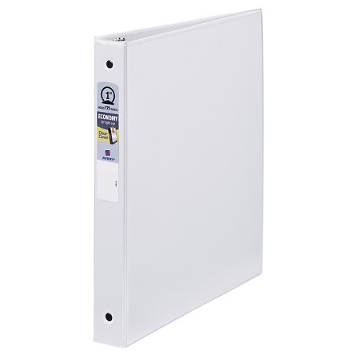
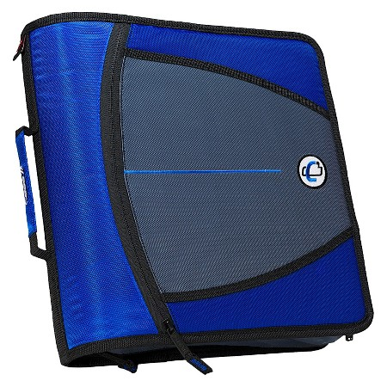
YOU WILL NEED:
(one) 3” zippered binder
(three) 1 inch binders with internal pockets
(two) 70 sheet single subject notebooks
A 3-ring zippered pencil pouch
A personal supply of pens and pencils
YOU MAY WANT:
Water bottle
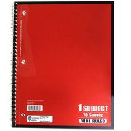
Calculator
CLASSROOM WISH LIST (items that will be shared with the class)

Disinfectant wipes
Hand sanitizer
Tissues
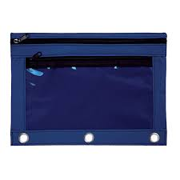
See you on August 31st!
Ms. Anderman + Mrs. Nedeau + Ms. Raczkowski

